Oil Pressure Gauge Sensor Based – CGEA1.3

Functional Description

The purpose of the sensor based Oil Pressure Gauge is to inform the driver of an accurate reading of the engine oil pressure and to notify the driver of unsafe engine operating condition due to low engine oil pressure.

The PCM is responsible for all filtering required for the input, the cluster simply drives the gauge to the indicated location.

The sensor based Oil Pressure Gauge Function correlates the EngOil_P_Actl signal from the PCM and Operational_Mode to generate a pointer position on the Oil Pressure Gauge.

This STSS is only applicable on programs that have a sensor based Oil pressure input. Programs using this STSS shall ignore the other STSSs for the Oil Pressure gauge.

Interfaces

Interface Context Diagram (I/O Block Diagram)
Figure 1 Oil Pressure Gauge Context Diagram 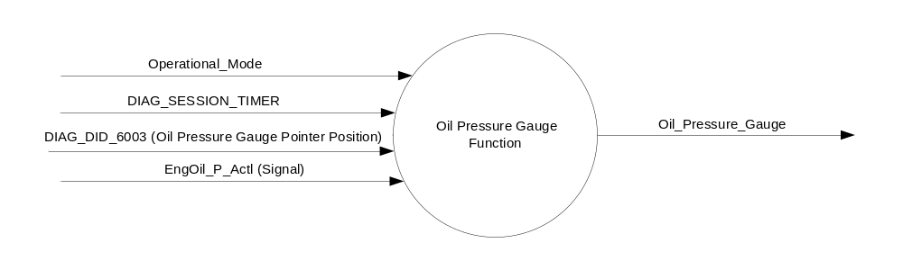

Inputs

- INTERNAL:
    - DIAG_SESSION_TIMER
    - Diagnostic DID 6003 (Oil Pressure Gauge Pointer Position)
    - Operational_Mode
- MUX signal on the CAN Bus

- EngOil_P_Actl Signal
Signal Name | Size  (bits) | Detail | Units | Res. | Offset | State  Encoded | Min. | Max.
EngOil_P_Actl | 10 |  | kPa | 1 | 0 |  | 0  (0x0) | 1023 (0x3FF)

Outputs
Oil Pressure Gauge Indication

Function/Performance

Operational Modes

Mode | Differentiating Vehicle Conditions
Sleep Mode | Oil Pressure Gauge needle at “Rest Position”
Limited Mode | Oil Pressure Gauge needle at “Rest Position”
Normal Mode | Oil Pressure Gauge needle at “Oil Pressure Gauge” indication
Crank Mode | Oil Pressure Gauge needle at "Oil Pressure Gauge" indication

Voltage Levels

Refer to Cluster Features table located in Master SPSS.

Human-Machine Interface

Visual

Indicator Graphics / Display Format

Indicator Color Coordinates

- Reference section COLOR & ILLUMINATION REQUIREMENTS (GRAPHICS)

Indicator Characteristics

Description of Gauge | Scale Range | Scale Span | Operating Span
North American | 0-100 psi | 0 – 144 angular degrees | 0 - 144 angular degrees

Audio

None

Switch Control Logic

None

System Accuracy

- Shall indicate within 100msec the data contained in EngOil_P_Actl signal.

Operation: Performance and Functional

Subsystem Algorithm Flowchart / State Diagram

Figure 2 Oil Pressure Gauge Control Flowchart

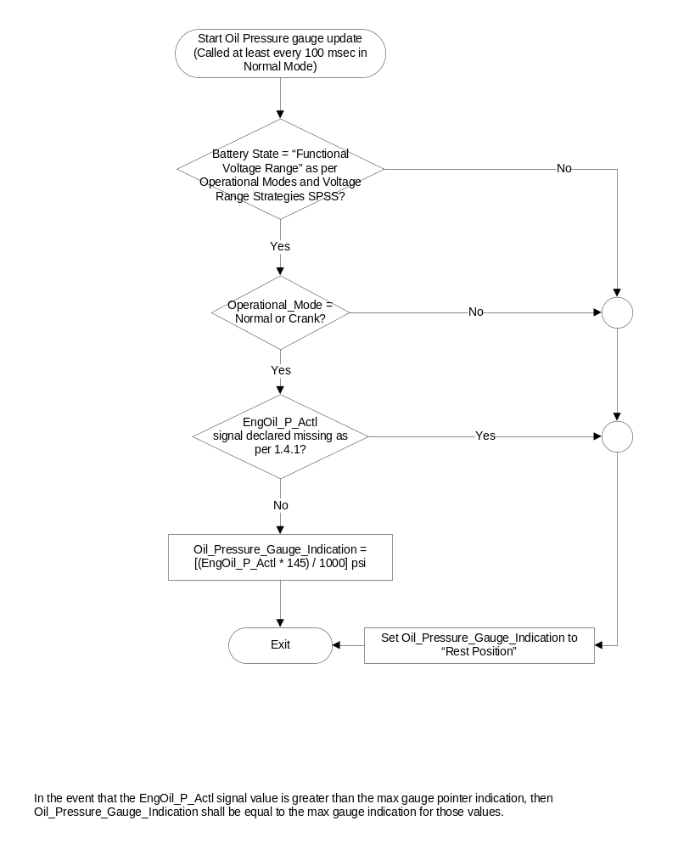

Operation Description (supports algorithm flowchart /state diagram)

- State Matrix for Oil Pressure Gauge
Operational_Mode | DIAG_SESSION  _TIMER | DIAG_DID_  6003  (Oil Pressure Gauge Pointer Position) | Oil_Pressure_Gauge
Normal or Crank | Not Active | X | As per Figure 2 - Oil Pressure Gauge  Control Flowchart
Normal | Active | Not Received | As per Figure 2 - Oil Pressure Gauge  Control Flowchart
Normal | Active | Received with Appropriated Data | Pointer Location per Diagnostic DID
All Other Cases |  |  | As per Figure 2 - Oil Pressure Gauge  Control Flowchart

- Gauge pointer shall move to Rest Position at max rate when EngOil_P_Actl signal is declared missing as per section 1.4
- Pointer overshoot and return to Oil Pressure value indicated by EngOil_P_Actl Signal shall not exceed one angular degree.
- Pointer movement shall appear smooth and continuous.
- Pointer shall not waver at constant position with constant command.
- No pointer stick shall be observed at any time.
- The cluster shall linear interpolate between input values to calculate the target position to ensure smooth pointer movement between targets.

Function Safety Classification (EMC)

B

Memory Storage

Parameter Name | Description | Value at Battery Connect | Value at Module Wake-up
Oil_Pressure_Gauge_Indication | Output Oil pressure gauge Indication | Rest Position | Rest Position
EngOil_P_Actl Signal | Oil Pressure Switch Input | 0 (0x0) | 0 (0x0)
DIAG DID 6003 | Oil Pressure Gauge Pointer Placement | 0 (0x0) | 0 (0x0)
Operational_Mode | 4 state indicator for cluster operational mode | Limited | Limited or Normal or Crank

Timer Name | Description | Value at Battery Connect | Value at Module Wake-up
DIAG_SESSION_TIMER | Timer used to time-out a diagnostic session | 0 | 0

Prove Out

No

Error Handling

Missing Message Strategy

The signals will be declared missing as per the Diagnostics section of this SPSS.

DTCs states and history will be determined as per the Diagnostics section of this SPSS.

Diagnostics

Self Test

None

Engineering Test Mode

Reference section “Dealer / Engineering Test Mode (ETM)”

Part II Performance

Reference Part II Diagnostic Specification

Supported Diagnostic DIDs (Service $22 and $2F)
Number | DID / CommonID Name | DID Type
6003 | Oil Pressure Gauge Pointer Position | Numeric

Supported Diagnostic Trouble Codes (DTCs)

DTCs shall be logged as per the diagnostic section of this SPSS.

DTC | Description
C10000 | Lost Communication With ECM/PCM

Reference Specification

- Func. Criticality EC-0048
- Mod. PWR-up / Reset EC-0049
- Low-High Vol. Perform. EC-0058
- Jump Start EC-0062
- Instr. & Gauges (indic. Grad) IS-0015
- Gauge Durab. IS-0033
- Oper. Voltage Functional/Perf. IS-0052
- Sys. Audible Noise IS-0103
- Pointer Waver IS-0108
- Instr. Scale Dir. IS-0127
- Pointer Position IS-0128
- Signal Logic: Communization IS-0129
- Sensor Packaging IS-0131
- Electrical IS-0132
- Oil Pressure Gauge IS-0316
- Vibration - Gauge Perf. IS-0326
- Temp. Warn. IS-0342
- Symbol Usage 01-0238 / 01-0239
- Symbol Leg. 01-0240
- Placement - Parts Loc. 03-0001
- Glare/Reflections 16-0068
- Reflection 17-0018
- Robust Sound Quality 17-0032
- Harmony: Graphics / Font / Ill. 17-0040
- Placement Vis. ID 17-0051
- Ergo - Access. 17-0052
- Ergo - Operability 17-0053
- Control & Display Loc. 17-0060
- Logical grouping Function and Usage 17-0062
- Assoc. of Controls with Disp. & elem. 17-0063
- Ill. Controls & Disp. 17-0074
- Id. Legibility 17-0081
- ID. Coding / Labeling 17-0083
- Logic of Op. 17-0120
- Op. Stereotypes 17-0121
- Interpretation 17-0122
- Feedback 17-0124

Revision History
SPSS Module Revision History

Revision Level | Name | Change Description | Date
1.0 | V.Patel | Initial release. | 2/12/2013

